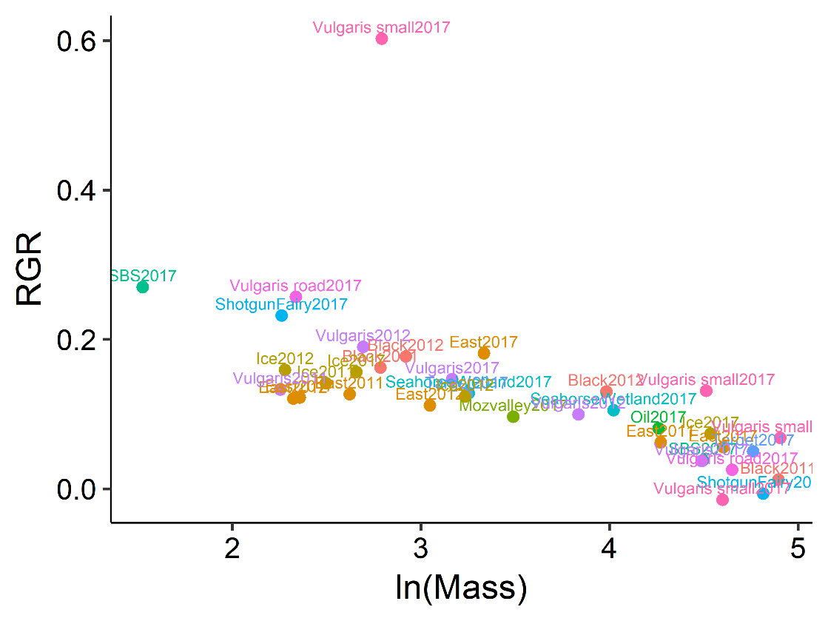

Linear model Relative growth rate as a function of ln(mass) larvae

lm(formula = RGR ~ lnmass.1, data = RGRtempponds)

Residuals:

Min 1Q Median 3Q Max

-0.08347 -0.03010 -0.01259 0.01276 0.42935

Coefficients:

Estimate Std. Error t value Pr(>|t|)

(Intercept) 0.35844 0.05089 7.043 3.36e-08 \*\*\*

lnmass.1 -0.06640 0.01410 -4.709 3.85e-05 \*\*\*

---

Signif. codes: 0 ‘\*\*\*’ 0.001 ‘\*\*’ 0.01 ‘\*’ 0.05 ‘.’ 0.1 ‘ ’ 1

Look at residuals of the above linear model vs. temp and N

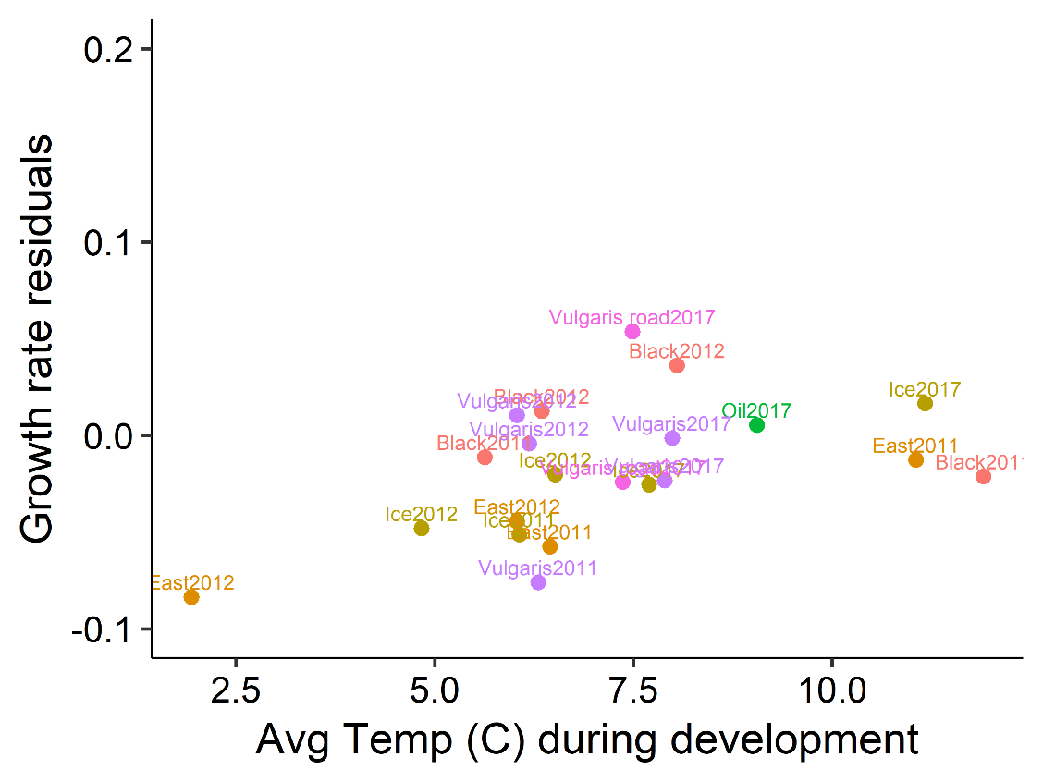

Use Growth rate instea

